Syeda Reeha Quasar

14114802719

4C7

Aim

To find the solution of algebraic and transcendental equations using

(a) Bisection method

(b) Newton- Raphson method.

Experiment - 4

APPLIED MATHEMATICS LAB

# **EXPERIMENT – 4**

## **Aim:**

To find the solution of algebraic and transcendental equations using

(a) Bisection method

(b) Newton- Raphson method.

**Source Code:**

**Newton RAPHSON**

***// Newton Raphson Method***

clc

printf('\n\n Name - Syeda Reeha Quasar \n Enrolment No. - 14114802719 \n Group - C7 \n\n')

deff ('x = f(x)', 'x = cos(x) - x * exp(x)')

deff ('x = f1(x)', 'x = sin(x) - (x+1) * exp(x)')

x0 = 0.5; e = 0.00001;

printf(' n \t xn \t\t f(xn) \t\t f1(xn) \t xn+1 \t Error \n\n')

for i = 1:4

x1 = x0 - f(x0)/f1(x0)

e1 = abs(x0 - x1)

printf(' %i \t %10f \t %10f \t %10f \t %10f \t %10f \n', i-1, x0, f(x0), f1(x0), x1, e1)

x0 = x1

if e1 < e then

break

end

end

printf('\n\n The solution of this equation after %i Iterations is %10f', i, x1)

# **Output:**

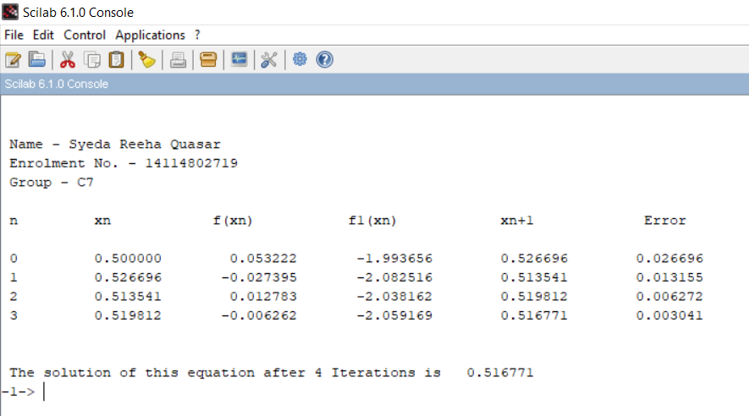

##### **Bisection Method**

*// Bisection method*

clc

printf('\n\n Name - Syeda Reeha Quasar \n Enrolment No. - 14114802719 \n Group - C7 \n\n')

deff ('y = f(x)', 'y = x^3- 4*x -9')

x1 = 2; x2 = 3; e = 0.001; i = 0;

printf('Iteration \t x1 \t\t\t x2 \t\t\t z \t\t\t f(z) \n')

while abs(x1 - x2) > 2*e

z = (x1 + x2)/2

printf(' %i \t\t %f \t\t %f \t\t %f \t\t %f \n', i, x1, x2, z, f(z))

if f(z) * f(x1) > 0 then

x1 = z

else

x2 = z

end

i = i + 1

end

printf('\n\n The solution of this equation is %g after %i Iterations', z, i-1)

# **Output:**

